ITMO 440/540 - Data Networks

Assignment 4

Assigned: 09/10/2013 Due: 09/17/2013

ANSWERS

Purpose: Practice using different line codes to encode data bits for transmission. The code books for all the line codes used in this homework are located at the end of this homework assignment.

Use the code books at the end of this homework to encode the following 12 bits in the data stream:

1 1 1 0 1 0 1 1 0 0 0 1

Example:
Question: Encode the bit stream above using the Unipolar line code indicated in the code book.

Answer: + + + 0 + 0 + + 0 0 0 +

Questions:
- Encode the bit stream above using the ‘Polar NRZ-L’ line code:

- - - + - + - + + - - - + _______________________________________________

- Encode the bit stream above using the ‘Polar NRZ-I’ line code.

- + - - + + - + + + + - ________________________________________________

- Encode the bit stream above using the ‘Manchester’ line code. The letters that you copy, indicate the direction of the transition between positive and negative polarity. U (up) means you transition from negative to positive; D (down) means you transition from positive to negative.

U U U D U D U U D D D U _____________________________________

- Encode the bit stream above using the Differential Manchester line code. The letters that you copy from the code book indicate if there is (Yes) a transition at the left edge of the bit interval or if there is not (No) a transition at the left edge of the bit interval.

N N N Y N Y N N Y Y Y N _____________________________________

- Encode the bit stream above using the ‘Bipolar AMI’ code. (The last non-zero signal had polarity +).

- + - 0 + 0 - + 0 0 0 - _____________________________________

- Encode the bit stream above using the Multilevel 2B1Q code. . (The last non-zero signal had polarity -).

+3 -1 +1 -3 -1 +3

- Use the unipolar line code to encode the bit pattern 000000111111. Assume that the ‘+’ in the code book corresponds to a voltage pulse whose value is +1 volt. What voltage would build up on the line? ( 0 + 0 + 0 + 0 + 0 + 0 + 1 + 1 + 1 + 1 + 1 + 1 ) /12 = 6/12 = .5 v _____________________________

- Use the NRZ-L scheme, to encode the following string of bits: 11111111.

- - - - - - - - ____________________________________

- Using NRZ-L, what is the average charge that is built up on the line while this string of 8 ‘1’ bits is being signaled? Assume that the ‘-’ in the code book corresponds to a voltage pulse whose value is -1 volt. (Add the voltage in each bit interval and divide by the number of bit intervals.) -8 V/8 bit intervals = -1 V _______________________________________________________

- Using the NRZ-L code book, draw the signal that is imposed on the channel when you send the bit string ‘11111111’. Use the axes below to draw the signal. You may draw this using the “shapes” utility in ‘Word.’ ( If you can’t do this, draw it by hand and describe your drawing below.)

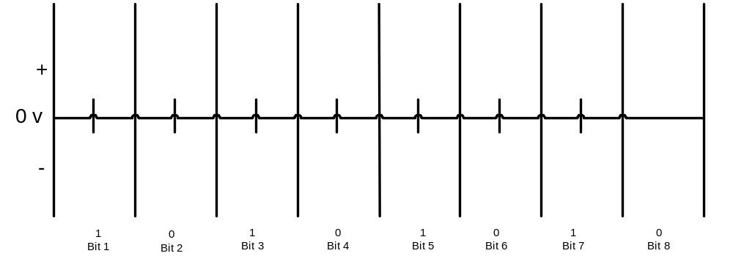

The graph consists of a straight horizontal line at the negative polarity below the x axis.

- Explain why the signal that you sent using the NRZ-L code book might cause a loss of synchronization at the receiving end. There would be no ‘knife edges’ or transitions between two different levels that the far end can use to pull up its clock to be in phase with the sender’s clock ___________________________________________________________________
--1 V

- What is the name given to voltage that built up on the line while you sent these 8 bits?

DC Bias _________________________________________________________________

- In both the Manchester code and the Differential Manchester code, there is always a transition from one polarity to the other. Where does that transition take place? _____________________________________________________________________
a) In the middle of the bit interval b) at the left edge of the bit interval

- In the Differential Manchester code the transition in the middle of the bit interval is used for which purpose below? _______________________________________________________________________
a) synchronization b) identifying whether the signal represents a ‘0’ bit or a ‘1’ bit

- Draw the signal that is created in the channel when we use the Manchester code to send the bit stream 11111111. (You may do this on paper and then describe your drawing in the space below if you have trouble drawing the lines on this digitally. )

The result is a square wave starting at the negative polarity and transitioning to the positive polarity in the middle of every bit interval. ___________________________________________________

- Will a charge build up on the channel that is carrying the signal that you sketched in question 15, above? Explain your answer. No, because in each bit interval half the energy is associated with the positive voltage and half the energy is associated with the negative voltage. The two cancel each other. ________________________

- Explain why the signal that you sent using the Manchester code book for the bit stream 11111111 will not cause a loss of synchronization at the receiving end. Every bit interval contains a knife edge in the middle. In addition, there is a knife edge at every bit edge because in every interval the signal must start negative and go to positive. So at each end of a bit interval the signal must again create a knife edge to go down to negative from positive. ___________________________________________________________

- Suppose we can create 8 different signal levels as shown in the code book below. Fill in one possible way to write the code book for the eight levels, assigning a distinct bit pattern to each level. I filled two of the values already. You could choose the others in many different ways. Just choose one.

Bit Pattern | Signal level
011 | +4 v
010 | +3 v
001 | +2 v
000 | +1 v
111 | -1 v
110 | -2 v
101 | -3 v
100 | -4 v

Code Books

Unipolar
Bit | Signal Polarity
0 | 0
1 | +

Polar : NRZ-L (the signal’s polarity is dictated by the bit value)
Bit | Signal Polarity
0 | +
1 | -

Polar : NRZ-I (the signal’s polarity is dictated by two things – the bit value and the polarity of the previous signal.
Bit | Polarity of last signal in the channel |  | Signal Polarity
0 | - |  | -
0 | + |  | +
1 | - |  | +
1 | + |  | -
For the problems in this homework, assume that the last signal on the channel had positive polarity.

Manchester (transition in the center of the bit interval defines the bit value)
Bit | Polarity of last signal in the channel |  | Center transition direction | Therefore, polarity at left edge of bit interval
0 | + |  | D | + no transition needed
0 | - |  | D | + transition from negative to positive
1 | + |  | U | - transition from positive to negative
1 | - |  | U | - no transition needed
For the problems in this homework, assume that the last signal on the channel had positive polarity.

Differential Manchester (transition at left edge of the bit interval defines the bit value)
Bit | Polarity of last signal in the channel |  | Polarity at left edge of bit interval | Transition at left edge
0 | + |  | - | Y
0 | - |  | + | Y
1 | + |  | + | N
1 | - |  | - | N
For the problems in this homework, assume that the last signal on the channel had positive polarity.

Return to Zero (RZ) (signal is always 0 at the end of the bit interval)
Bit | Signal polarity at left edge of bit interval
0 | -
1 | +

Bipolar: AMI
Bit | Last Signal Polarity |  | Signal Polarity
0 | xxxxxxxxxxxxxxxxxxx |  | 0
1 | + |  | -
1 | - |  | +
For the problems in this homework, assume that the last signal on the channel had positive polarity.

Multilevel: 2B1Q
Bit Pattern | Last Signal Polarity |  | Signal Value
00 | + |  | +1
00 | - |  | -1
01 | + |  | +3
01 | - |  | -3
10 | + |  | -1
10 | - |  | +1
11 | + |  | -3
11 | - |  | +3
For the problems in this homework, assume that the last signal on the channel had positive polarity.

